Read a CSV into a datatable

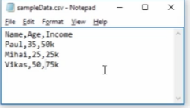

Application Integration \ CSV \ Read(CSV)

|  |  |
| --- | --- |
|  |  |
| n properties select the   * File path * Include column names, * the first column has the field names   Set the output variable sampleData |  |

When we type sampleData as output it will create a variable type DataTable at the bottom

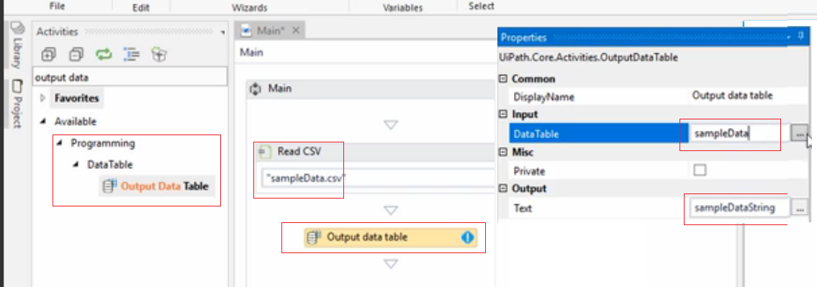

Iteract

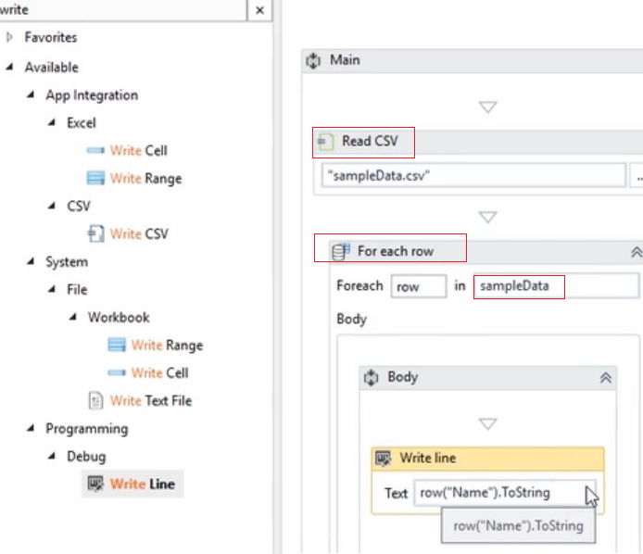

We can query a sub array

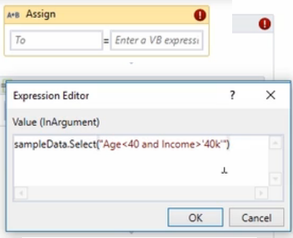

Create a new array according to this conditions, and assign to a variable

La variable se escribe y aparece abajo, pero hay que darle definition

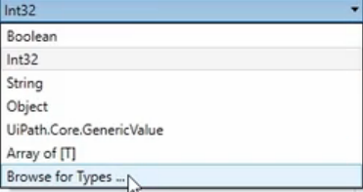

Type **DataRow**

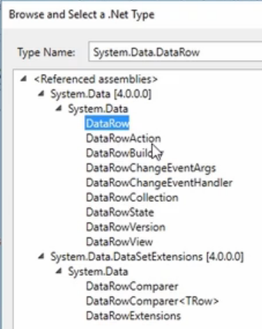

Asi el foreach is different

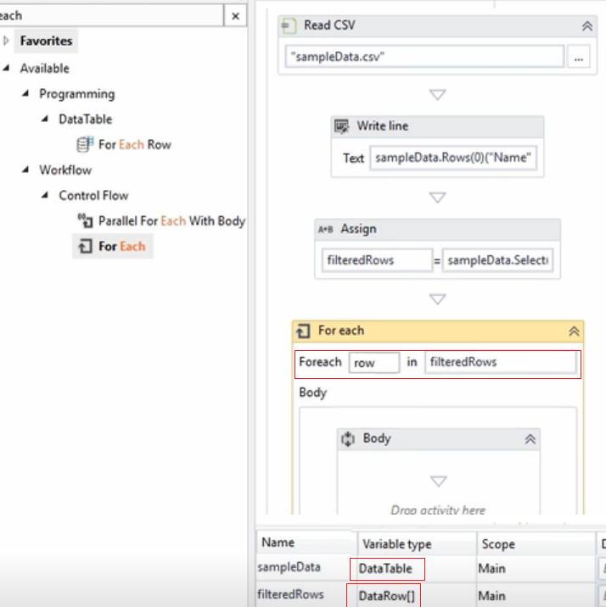

Display

row(“Name”).ToString+” “+row(“Age”).ToString

The variable must be an Array (T) and